Quantitative Evaluation of LoRa RF Resiliency, Detectability, and Geolocation

Project Description
This project aims to characterize the performance of the LoRa Radio Frequency (RF) Chirp Spread Spectrum (CSS) modulation with methods used by Department of Defense (DoD). Valuable characteristics for DoD applications include Anti-Jam performance, Probability of Detection, and Probability of Geolocation. Communication technologies that perform well in these categories allow for reliable communication in situations where communication is expected to be jammed and/or scenarios where transmitter activity is monitored but desired to be undetected or non-locatable.
LoRa is an extremely low power, cost effective, and long-range method of wireless communication usually combined with the LoRa Wide Area Network (LoRaWAN) protocol for applications such as asset tracking, Internet Of Things (IoT), and sensor monitoring. LoRaWAN will not be used in this project and a custom, test protocol will be developed to evaluate the LoRa CSS modulation technique independently. Data rates for LoRa can reach 0.3-50kbps depending on spread factors chosen which can be considered limiting in many applications, but the performance benefits of long range (>15km LOS), extremely low cost, and extremely low power consumption could be highly desirable in certain applications.
Other desirable characteristics are low receiver sensitivity (-120 to -145dBm) and built in forward error correction coding. These characteristics could prove valuable for resiliency to jamming and operation at low SNR which gives LoRa the long range capabilities but could also prove valuable for low detection of probability performance when operating at lower output levels.
This evaluation is part of Capstone Project for the Wireless Embedded Systems, Masters of Advance Study Program at University California San Diego (UCSD) and is a collaboration with Naval Information Warfare Center, Pacific (NIWC Pac) Division 535. Equipment and facilities at NIWC Pac will be leveraged to conduct the evaluation and the UCSD Student will acquire, develop and bring Heltec LoRa radio development boards to the facility. The UCSD Student will develop necessary code on the Heltec boards to exercise end-end data through LoRa and run the tests with provided equipment training. A Paper of quantitative results and analysis will be delivered as the output of this project as the Minimum Viable Product (MVP).

Methods of Evaluation

Anti-Jam and Range Performance
This evaluation method assesses LoRa’s resilience to jamming and its ability to maintain reliable communication over extended distances under contested and low-probability-of-detection (LPD) conditions. The Range Ratio (Jamming) metric is defined as the ratio of the distance to a friendly receiver versus the distance to a jamming threat while the Range Ratio (Detection) metric is defined as the ratio of the distance to a friendly receiver versus the distance to a threat detector in an LPD environment.
By measuring these ratios under varying SNR levels and jamming scenarios, the project quantifies LoRa’s effectiveness in maintaining secure and reliable links in both jammed and covert operational environments

Detection Avoidance Performance
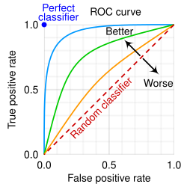
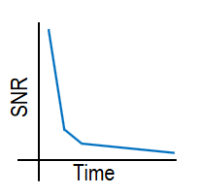
The detection avoidance evaluation quantifies LoRa’s ability to evade interception by analyzing its probability of detection under varying SNR conditions. This assessment relies on two key graphical tools: the Receiver Operating Characteristic (ROC) curve, which plots the probability of true positive detections (correctly identifying LoRa signals) against false positive detections (incorrectly flagging noise or interference as signals), and the Slash curve, which depicts the relationship between SNR and integration time for a given probability of true detection and false detection. Together, these metrics reveal how effectively LoRa can operate undetected, particularly at low output power levels or in low-SNR environments, by showing the trade-offs between detection reliability and false alarms.

Figures: ROC and Slash Curve Examples

Geolocation Avoidance Performance
This evaluation examines LoRa’s resistance to geolocation by analyzing the ambiguity of its RF signals using Cross Ambiguity Function (CAF) analysis. By processing RF recordings of LoRa transmissions, the CAF assesses how difficult it is to pinpoint the transmitter’s location, which is essential for low-probability-of-intercept (LPI) and low-probability-of-detection (LPD) applications. The results will demonstrate LoRa’s effectiveness in obscuring transmitter position, a key advantage for secure and covert communications.

Iterative Testing Approach
Multiple test runs will be executed with varying LoRa configurations (Spread Factors, Bandwidths, etc) chosen to obtain meaningful results in how these characteristics of the chirp spread spectrum affect performance across these metrics. For example, how will a larger or narrower spread factor along with a larger or narrower bandwidth effect the performance of LoRa and what configurations are most ideal or less ideal for individual areas of evaluations.
5-10 Lora Configurations will be selected and ran to determine the effects on performance. The delivery of the paper will analysis these and attempt to conclude what configuration or aspects of the LoRa waveform are ideal or not ideal for these applications.
At the time of this document’s creation, the details of all configurations and the number of configurations to be tested have not been fully defined. Defining these configurations is built into the schedule as part of development.

Deliveries

Minimum Viable Project (MVP)
The MVP for this project is demonstration of a working Heltec LoRa test application to run two LoRa radios in a valid test bed environment and a document outlining the test application development, test environment, and quantitative results from running the system through the test environment. This report will make conclusions and assessments regarding the LoRa modulation technique and its overall performance in the key evaluation areas. It will evaluate a range of spread factors and bandwidths to determine which configurations are most ideal.

Extensions
A number of extensions are included from most likely to least likely in the event the MVP is achieved ahead of schedule:
- The report will provide greater research depth into the algorithms and mathematics for the ROC and Slash Curves, CAF, and Signal Detection.
- The LoRa system will be configured to attempt to intercept Starlink LoRa messages or other UCSD Master’s projects that use LoRa as part of their demos potentially leveraging insight from the MVP.
- The report will provide greater research depth to evaluate the effectiveness of the specific algorithms and mathematics of item 1 and attempt to identify opportunities for more robust methods.

Risk Management
A list of risks and their mitigation steps are provided below:
- Relative performance of LoRa in the areas of evaluation risk revealing classified performance of existing technologies.
  - The report will avoid any and all language regarding relative terms such as “performs exceptional” to avoid potential reveal of relative performance.
  - The report will only report on results independently.
  - Publicly available research in similar areas will be searched to compare unclassified results to other technologies.
- Brining devices into a classified space (and especially back out) could present security violations.
  - Coordination with lab facility personal and COMSEC users will be consulted.
  - All other wireless functions of the Heltec boards or laptop equipment will be disabled.

Roles and Responsibilities
There is only one member on this team. They are responsible for all aspects including scheduling, decision making, development, and coordination.

Development

Software Development Overview
This development effort will require the UCSD student to develop and demonstrate a functional test application to exercise data exchange through LoRa and develop functional code at the Heltec boards to include LoRa configuration and integration with the laptop for configuration and data capture capabilities. The application will be responsible for generating data to transmit to the remote Heltec dev board and capturing status of successful ACKs and basic goodput status. The application will send this data externally to a laptop for recording and analysis and logging purposes. The Primary Heltec Board will integrate with the laptop via a USB-C serial interface.
The primary Heltec board will send a fixed length and predetermined string of messages to the remote board with a message length determined to maximize throughput. The remote board will receive the message, check for message integrity, and respond with a small ACK message before the primary board resumes the next transmission cycle. The remote board will also populate the ACK message with goodput values calculated from the expected received string of message. This will allow logging of a running average of goodput to use for analysis of link break points. The ACK messages will be passed to the laptop for logging over the course of the test.
A System level diagram for the development of a valid LoRa end-end system is shown in the figure below.
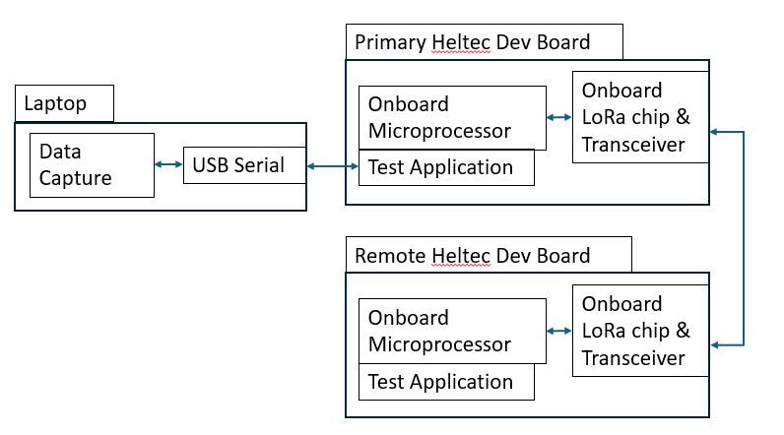

Development Tools

Visual Studio Code
A lightweight yet powerful integrated development environment (IDE) that will serve as the primary platform for writing, debugging, and managing the project’s codebase. VS Code’s extensibility and support for multiple languages make it ideal for developing the custom test protocol and LoRa firmware.

Platform IO
A VS Code extension that simplifies embedded development by handling board-specific configurations, library dependencies, and build automation. PlatformIO will streamline the process of compiling and flashing code to the Heltec LoRa development boards, ensuring compatibility with their hardware while reducing setup complexity.

GitHub
A cloud-based version control and collaboration platform that will host the project’s code repository, enabling secure tracking of changes, issue management, and documentation. GitHub will facilitate version-controlled updates to firmware and act as a repository for all test scripts, results graphs, and the final Report Paper for project deliverables.

Arduino Libraries
Pre-built software libraries designed for Arduino-compatible boards, including LoRa-specific functions for configuring spread factors, bandwidth, and coding rates. These libraries will be leveraged to accelerate development, allowing the project to focus on testing and evaluation rather than low-level protocol implementation.

Testing Infrastructure
A figure of the test infrastructure is below. Data capture and outputs of the test are shown in red.
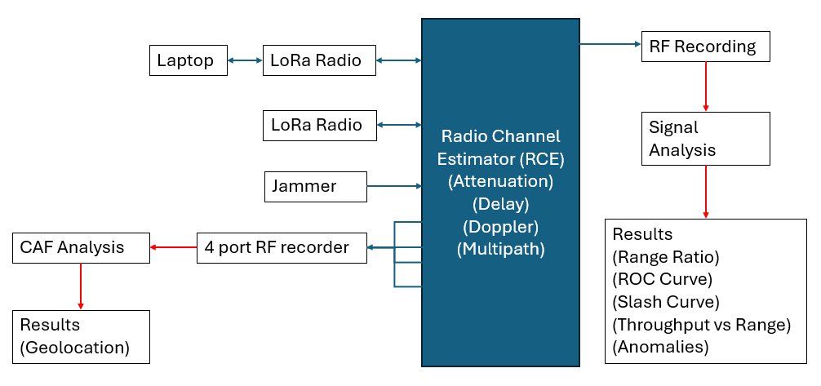

Equipment definitions

Heltec V3 Development Board
The WiFi LoRa 32 V3, also called Heltec V3, is a durable IoT maker kit powered by the ESP32S3 MCU and SX1262 LoRa Node chips made by Heltec Automation. LoRa, BLE, and Wi-Fi are integrated along with an on-board OLED display to present a robust, all-in-one solution for communication development. The RF design and stable, minimal system design ensure the product is ready-to-use “out of the box,” and its support for development methods like Arduino, Platform IO, ESP-IDF, and MicroPython make it beginner-friendly. It is now widely used in well-known long-range wireless open-source projects such as Meshtastic and Meshcore, serving applications in smart cities, smart farms, industrial control, and security systems.
Main Features:
- Microprocessor: ESP32-S3FN8 (Xtensa® 32-bit LX7 dual-core processor, five-stage pipeline rack Structure, frequency up to 240 MHz).
- SX1262 LoRa node chip.
- Type-C USB interface with a complete voltage regulator, ESD protection, short circuit protection, RF shielding, and other protection measures.
- Onboard SH1.25-2 battery interface, integrated lithium battery management system (charge and discharge management, overcharge protection, battery power detection, USB / battery power automatic switching).
- Onboard 0.96-inch 128*64 dot matrix OLED display can be used to display debugging information, battery power, and other information.
- Integrated WiFi, LoRa, Bluetooth three network connections, onboard Wi-Fi, Bluetooth dedicated 2.4GHz metal spring antenna, reserved IPEX (U.FL) interface for LoRa use.
- Integrated CP2102 USB to serial port chip, convenient for program downloading, and debugging information printing.

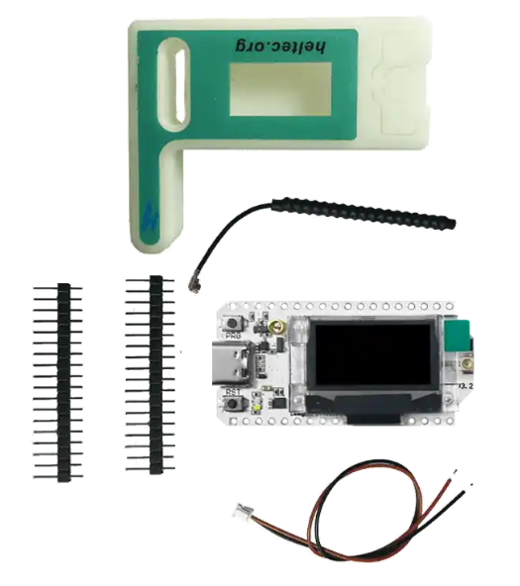
Source: Heltec Automation

LoRa
The LoRa Chirp Spread Spectrum modulation is a proprietary radio technique developed by a French company, Cycleo, and acquired by Semtech in 2012. LoRa is an extremely low power, cost effective, and long-range technique of wireless communication usually combined with the LoRa Wide Area Network (LoRaWAN) protocol for applications such as asset tracking, Internet Of Things (IoT), and sensor monitoring.

Radio Channel Emulator (RCE)
The RCE is a recently developed piece of equipment by NIWC Pac division 535 for the purposes of Advance Tactical Data Link (ATDL) evaluation. This equipment acts as a simulated environment to test radio hardware in a lab setting and can simulate attenuation, delay, doppler shift, and multipath based on chosen geographical locations and movement scenarios. The user interface allows for selection and movement of the radios to orchestrate real world scenarios to bring quantitative performance analysis and comparison of various communication systems.

Signal Analysis and Detection (SAD)
After execution of the desired scenarios, the RF recordings of the system under test are ran through algorithms designed to capture metrics including ROC/Slash curves, Range Ratio performance graphs, and other metrics. The details of the SAD will be researched and reported on as part of the MVP of this project to the extent possible in the unclassified setting.

4-Port Rf Recorder for CAF Analysis
The device used to record reception for post-test CAF analysis is a 4 port RF recorder. Within the RCE, each port will be assigned geographical offsets to capture 4 distinct points for CAF analysis.

Project Milestones and Schedule

Schedule Overview
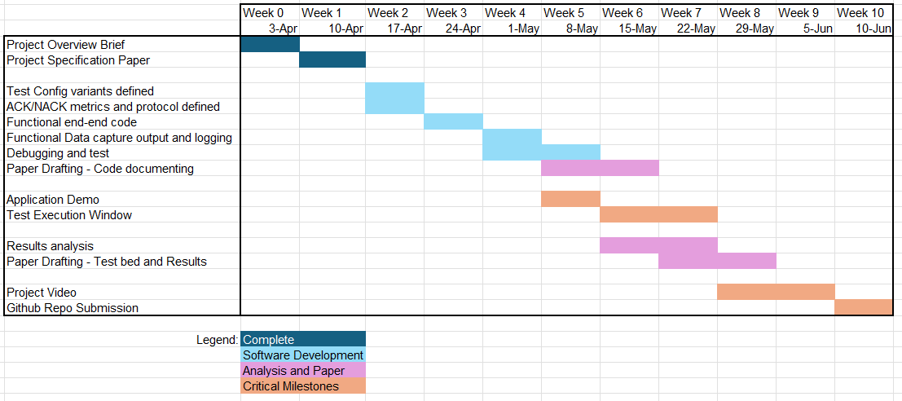

Schedule and Milestone Details

Software Development Schedule
Software development is scheduled to run week 2 through week 5. Previous LoRa code base will be leveraged from WES 269 to shorten LoRa configuration set up and operation on the Heltec boards. The bulk of the development will be focused around defining specific RF configurations to be tested, defining the protocols for message exchange and developing the necessary protocol control to test these configurations and handle data output metrics to log at the laptop.

Paper Drafting and Documentation
The primary MVP and delivery of this project is based around a paper covering the methods of test, development of the test application, and results of the test. The paper will have 3 major sections for reporting which are built into the schedule. The documentation of the code base and system under test will be drafted during and after the development. The documentation of the test bed and methods of test will begin drafting during and after test execution. The final analysis and results drafting along with meaningful analysis of the metrics will be drafted towards the end of the project schedule as the final portions of the paper.

Application Demo
This is the next critical milestone after submission of this document. The application and software is planned to be demonstrated to the cohort and show the logging and capture of end-end traffic as will be tested. It is also planned to have a coordinated date for execution available by this milestone.

Test Execution Window
After coordination with NIWC Pac, the most likely window of opportunity for test is week 6 or 7. As an extension, if the codebase is ready for test, the execution could be performed in week 5 and initial metrics could be presented as part of the demo.

Project Video
This is the required submission date for a video, however, due to the nature of this project being in the realm of research/test, there is not a product to show in a video. Additionally, the test bed is in a classified environment and recordings cannot be taken. This milestone will be discussed further with the UCSD advisor.

Github Repo Submission
All code development will be worked within a github repo and backed up throughout development. This is the final date that all content must be within the repo and the repo must be available to UCSD faculty.

